Office
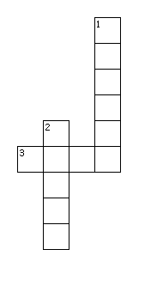
Across
3. They have ink and we write with them.
Down
1. We sit on them and they have four legs.
2. Have a flat top and four legs sometimes they have drawers.

