Classroom
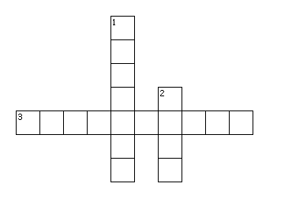
Across
3. The teachers writes notes on it.
Down
1. They come in different colors and the teachers write with it on the white board.
2. Has covers and we study from it.

