Nature
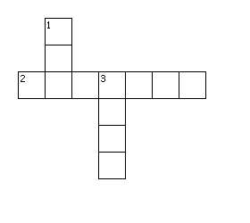
Across
2. Have four legs and some are wild in the forest.
Down
1. Round and yellow in the sky.
3. Round sometimes full or half a circle in the sky.

